Volume Study Guide

Volume is the space inside an object. It is always measured in units cubed or units³.

The formula is: $V=Bh$
B = the area of the base of the prism
h = the height of the prism

It really helps to outline the base of the shape you are finding the volume of so that you don’t get fooled about what the height of the prism is.

Ex: Find the volume of this rectangular prism.
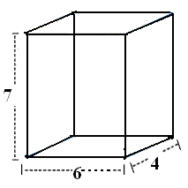
$V=Bh$
$V=\left(6∙4\right)∙7=168 u^{3}$

Find the volume of this triangular prism.
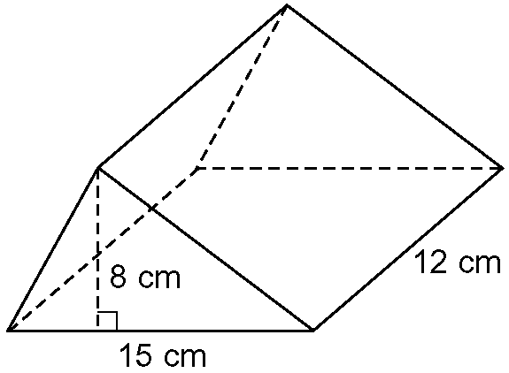
$V=Bh$
$V=\left(\frac{8∙15}{2}\right)∙12=720 {cm}^{3}$

Find the volume of this cylinder.

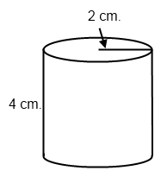
$V=Bh$
$V=(π2^{2})∙4=50.3 {cm}^{3}$

If you know the volume how do you work backwards? Just like with area, start with the formula.

Ex: The volume of a cylinder is 800ft³. If the cylinder has a radius of 3ft, what is it’s height?

$V=800$ * What is the formula for volume?
$B h=800$ * You know how to find the area of the base of a cylinder
$(π3^{2})∙h=800$ * $π3^{2}=28.3$
$\frac{28.3∙h}{28.3}=\frac{800}{28.3}$ * Now solve for h (you want to get h by itself, so divide)

$h=28.3ft$

