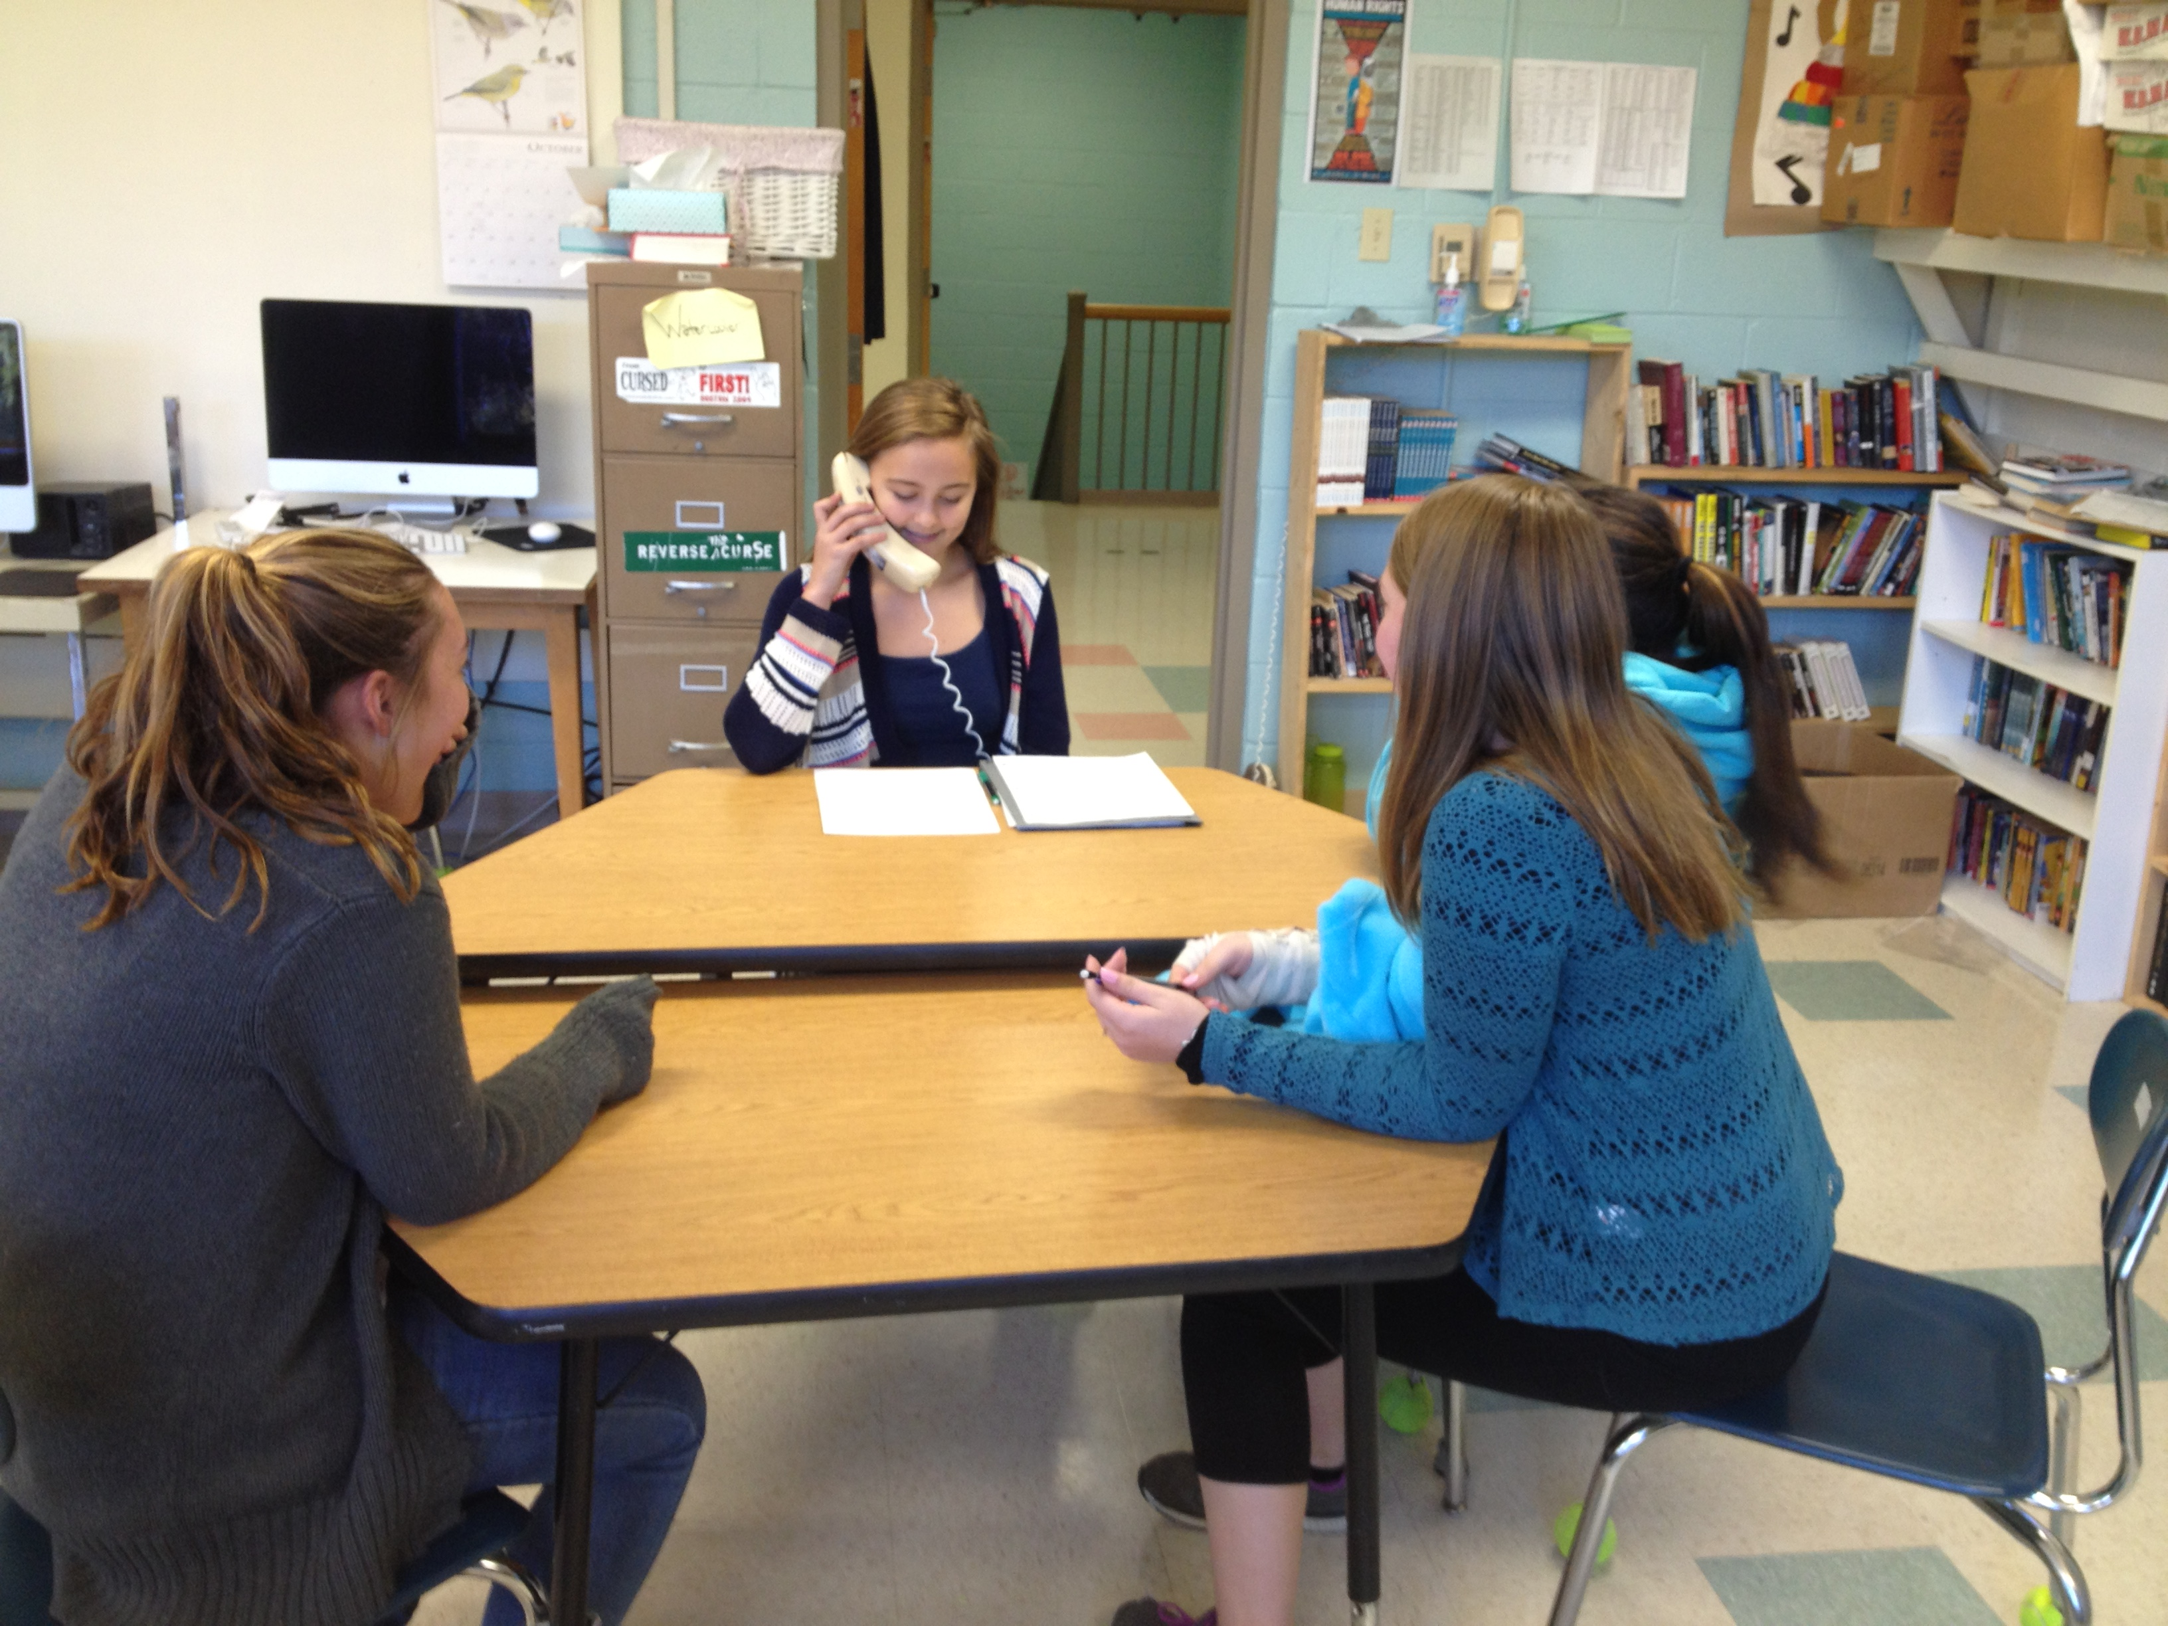

Week of October 26th-30th

Announcements & Upcoming Events:

Please return the SEL Parent Survey as soon as possible to your child’s homeroom teacher or to [ewhitney@sau21.org](mailto:ewhitney@sau21.org)

THANK YOU!

**MONDAY -** “DRUGS GIVE YOU THE BLUES!” – wear blue to school

**TUESDAY -**“UNITED WE STAND AGAINST DRUGS!”- wear red, white & blue to school

**WEDNESDAY –**  “BEING DRUG FREE IS NO SWEAT!” –wear sweats

**THURSDAY -** “TEAM UP AGAINST DRUGS!” –wear sports themed clothes

**FRIDAY -**FOCUS DAY – WEAR RED! – school assembly

Friday, October 30th- Trick of Treat starting at 4PM

Language Arts:

Monday you’ll have a focus day on your Edublogs and we’ll spend the day writing a new blog post about your Math Unit of drawing like the Ancient Greeks. You also have your 4th Reading Response due on Friday. We’ll continue getting ready for our final drafts of the One Stories with some class activities this week.

Friday we’ll return to our practice of writing by having a “Free-Write Friday.” Come prepared with an idea to write about that day. We’ll also build in time for sharing.

Friday- Reading Response #4 DUE

**Math:**

This week we will be starting a new procedure in math.  We will spend the first 10-15 minutes of each class on goal work related to the number system.  You will get all set up today in class.  We will spend the rest of class continuing to work on nets and surface area.  You will also get your circle quizzes back this week.  Looking ahead, our Geometry unit is almost at an end, which means the unit test is coming up on Nov 12 and 13.  We will review Nov 9-11.  Be sure to get all your questions answered before the test!

Homework due on:

Friday: Surface Area HW due and parent signature

7TH GRADE WEEKLY OVERVIEW

**SCIENCE**:

This week in science we will wrap up our weather unit with Severe Storm group presentations on Monday. We will have a couple review days and then students will start the end-of-unit Weather Exam on Thursday and finish up on Friday.

**Homework**: Study for the end-of-unit Weather Exam a little each night!

ESPAÑOL:  **“No hay pan sin corteza."** *(There is no bread without crust.)*

Español de la Comunidad (Mon):  El Carrusel, part 1 (Mini Books with el señor W, Board Games with la señora Tharp or Technology with los señores Johnston y Brown)

Miércoles (Wed):  DUE - AR  ER IR verb conjugation sheet. Actividades Mixtas.

Viernes (Fri):  AR ER IR Conjugaton Practice Quiz

Social Studies:

This week you’ll continue your work on understanding the Constitution and in our activity we’ll work on evaluating online resources for credibility. Don’t forget to complete your research for homework as well as class work during your research rotation each week. We’ll also start to prepare for the unit test on the Constitution this week.

DUE Friday- Research