Surface Area Study Guide

- Prisms: Two congruent, parallel bases connected by flat faces. Prisms are named for their bases.

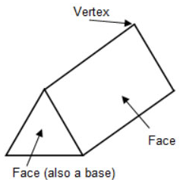
Edge

- Surface Area: The sum of the areas of all the shapes that cover the surface of a solid.

- Net: A figure that can be folded to form a model of a solid. The net shows all the surfaces of a solid and is useful to find the surface area of the solid.

