Area of Circles Study Guide

Remember: Circumference = $C=2πr$
Area of a rectangle = A_{T} = bh
Area of a parallelogram = A_{P} = bh

Where does the formula for the area of a circle come from?
Cut the circle into wedges and arrange them into a parallelogram:

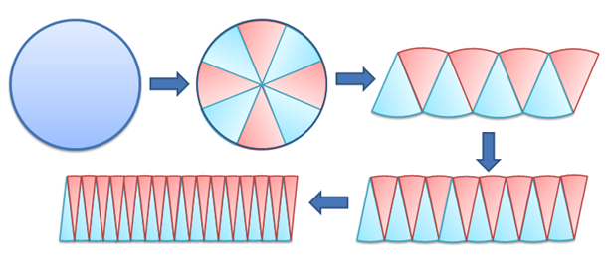

The smaller the wedges, the closer the circles gets to a parallelogram.

To find the area of a parallelogram we need the base and the height: A_{P} = bh

The height is the radius of the circle. $h=r$

The base is half of the circumference of the circle: $b=\frac{C}{2}$

We don’t want two variables in our formula so lets change C to 2πr: $b=\frac{2πr}{2}$

$\frac{2}{2}=1$ so lets simplify: $b=πr$

Now lets plug that information into the area formula for the parallelogram:

A_{P} = bh = $πr∙r=πr^{2}$

Now lets use it! If the radius of a circle is 3 cm, what is the area?

A = $πr^{2}=π3^{2}=28.27{cm}^{2}$ *Don’t forget to round properly and write the units!

What if they don’t give you the radius, but they give you the diameter?
Ex: What is the area of a circle if the diameter is 7 in?

Cut the diameter in half to get the radius! $r=\frac{7}{2}=3.5$

$$A=πr^{2}=π{3.5}^{2}=38.48{cm}^{2}$$

Now lets use the formulas to work backwards:

If the area of a circle is 490.63 ${cm}^{2}$, what is the radius?

$A=490.63{cm}^{2}$ *Put in the formula for area, so you can simplify

$πr^{2}=490.63$ *Divide both sides by $π$
÷$π ÷π$

$r^{2}=156.17$ *Now undo squaring with square root
√ √

$r=12.50 cm$ *Don’t forget to round properly and write the units!

If the circumference of the circle is 150.7 in, what is the radius?

$C=150.7in$ *Put in the formula for circumference, so you can simplify

$2πr=150.7$ *Divide both sides by $2π$ to get r by itself, remember to use parenthesis in $÷2π ÷2π$ your calculator so it does the correct order of operations

$r=23.98 in$

